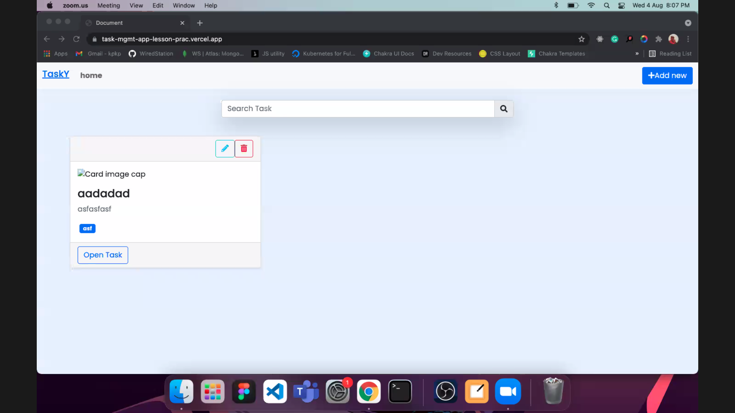

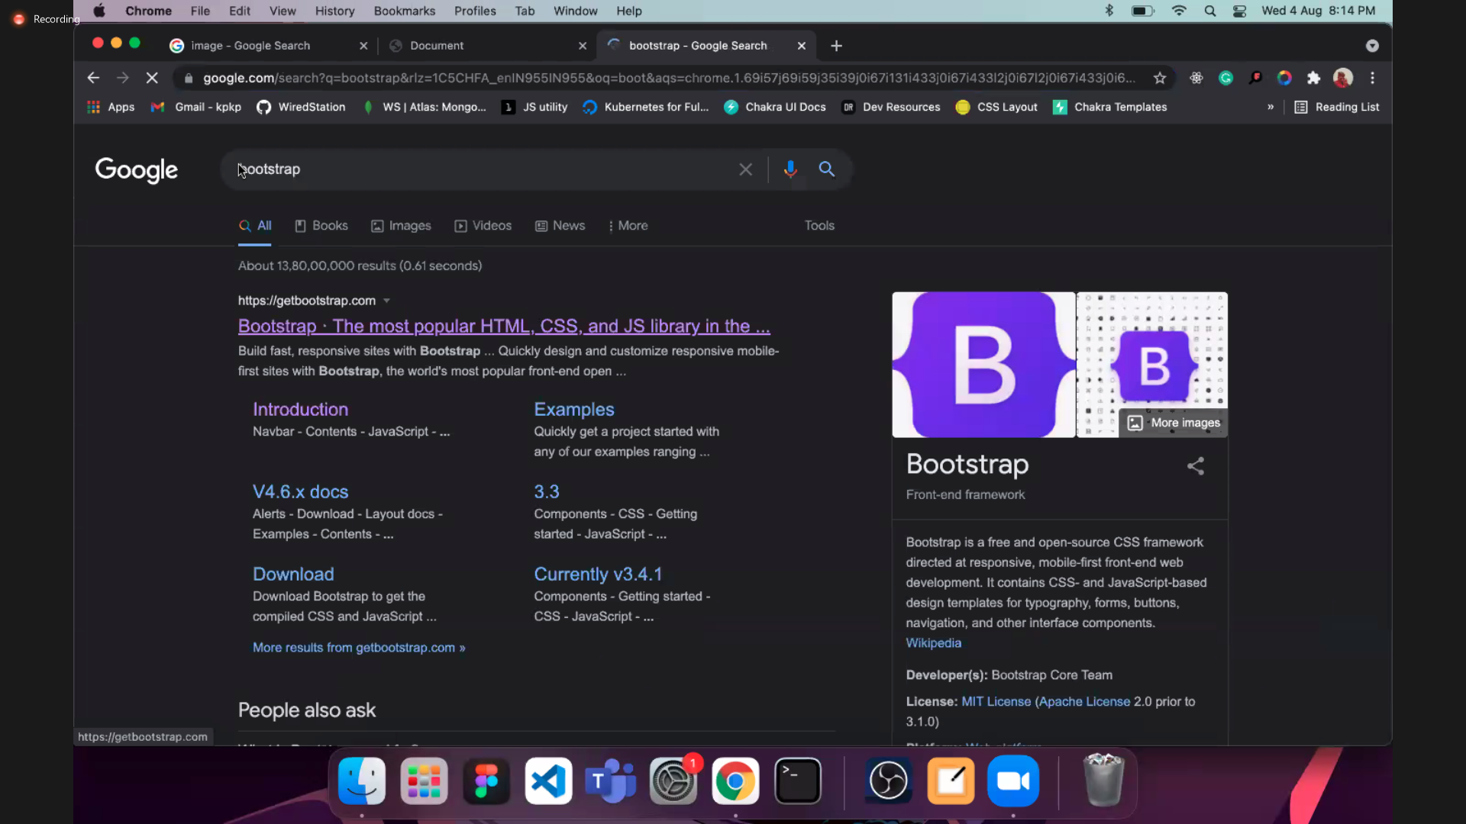

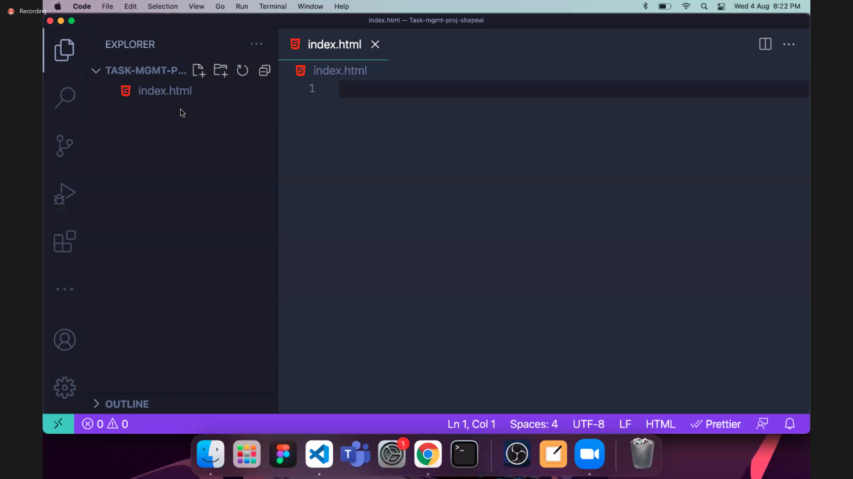

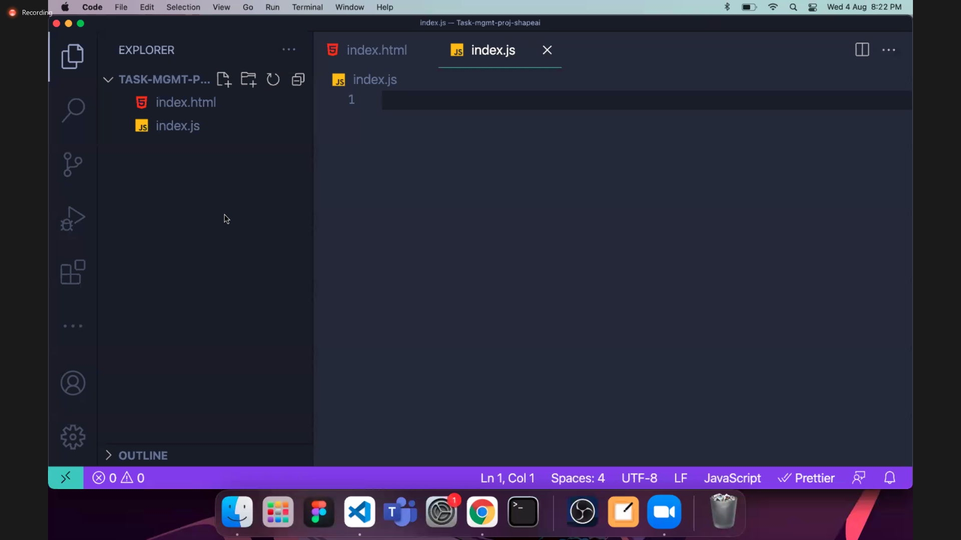

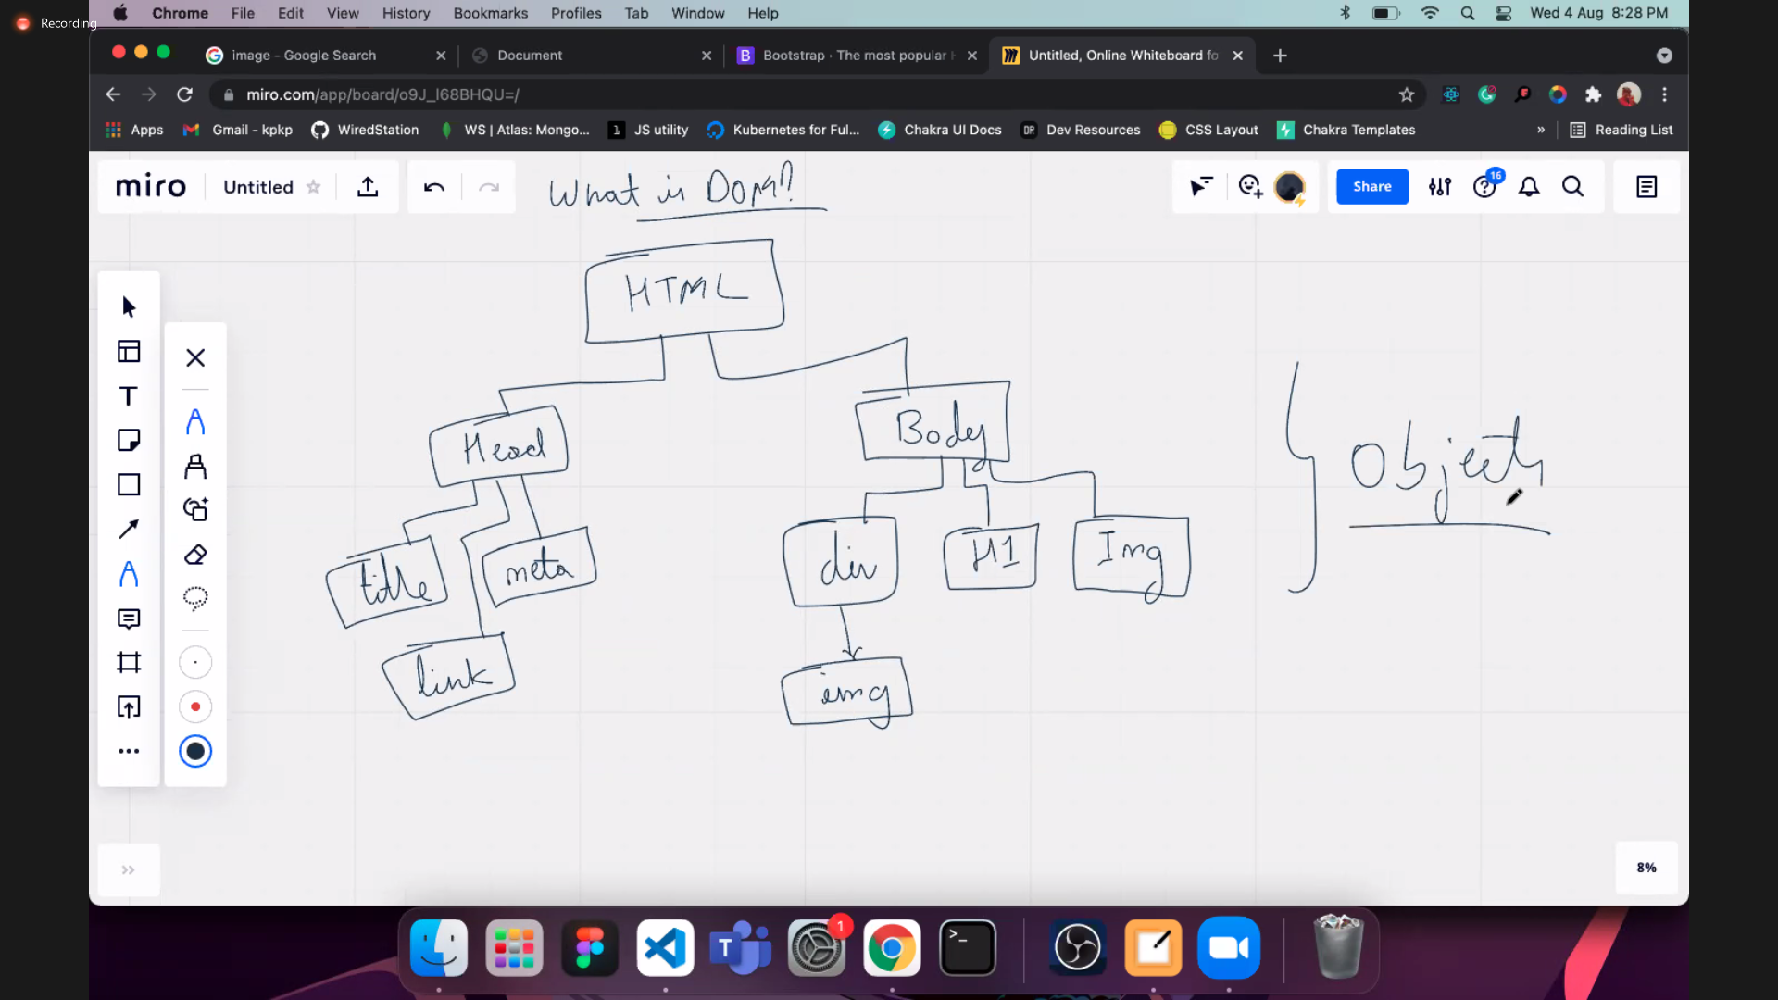

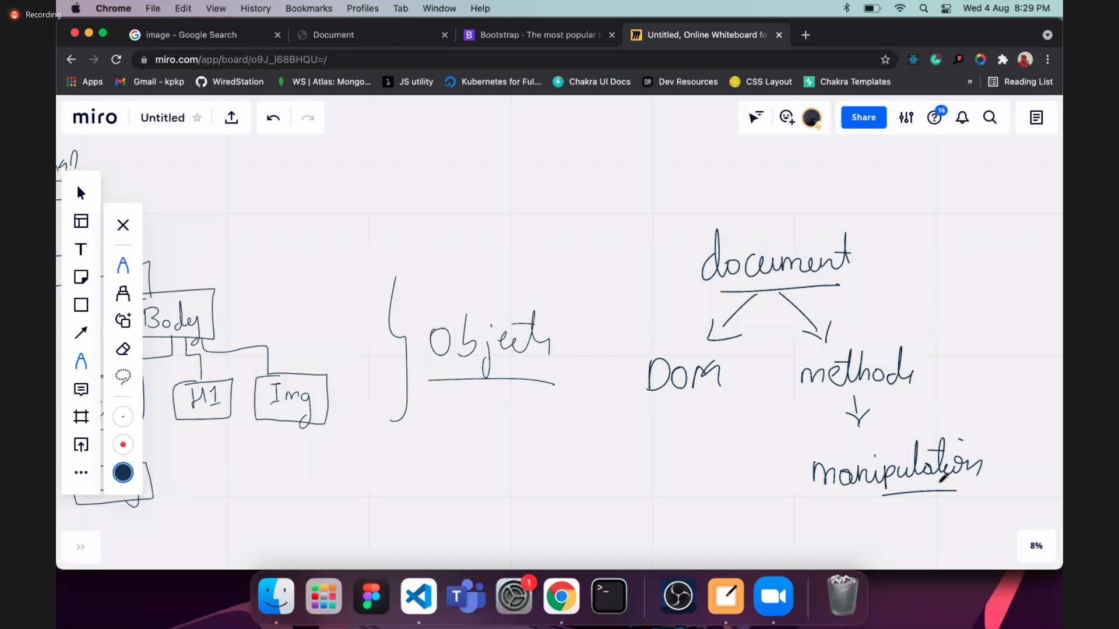

Document gives u access to the DOM and methods which is used to manipulate DOM.

Document is the parent object of JS. Document is a JS object.

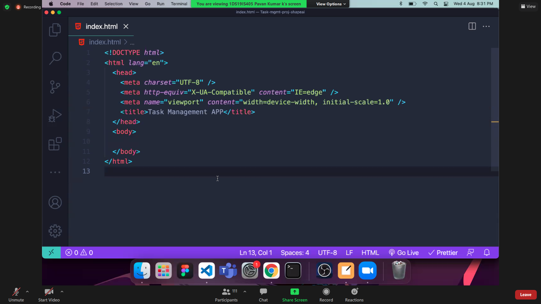

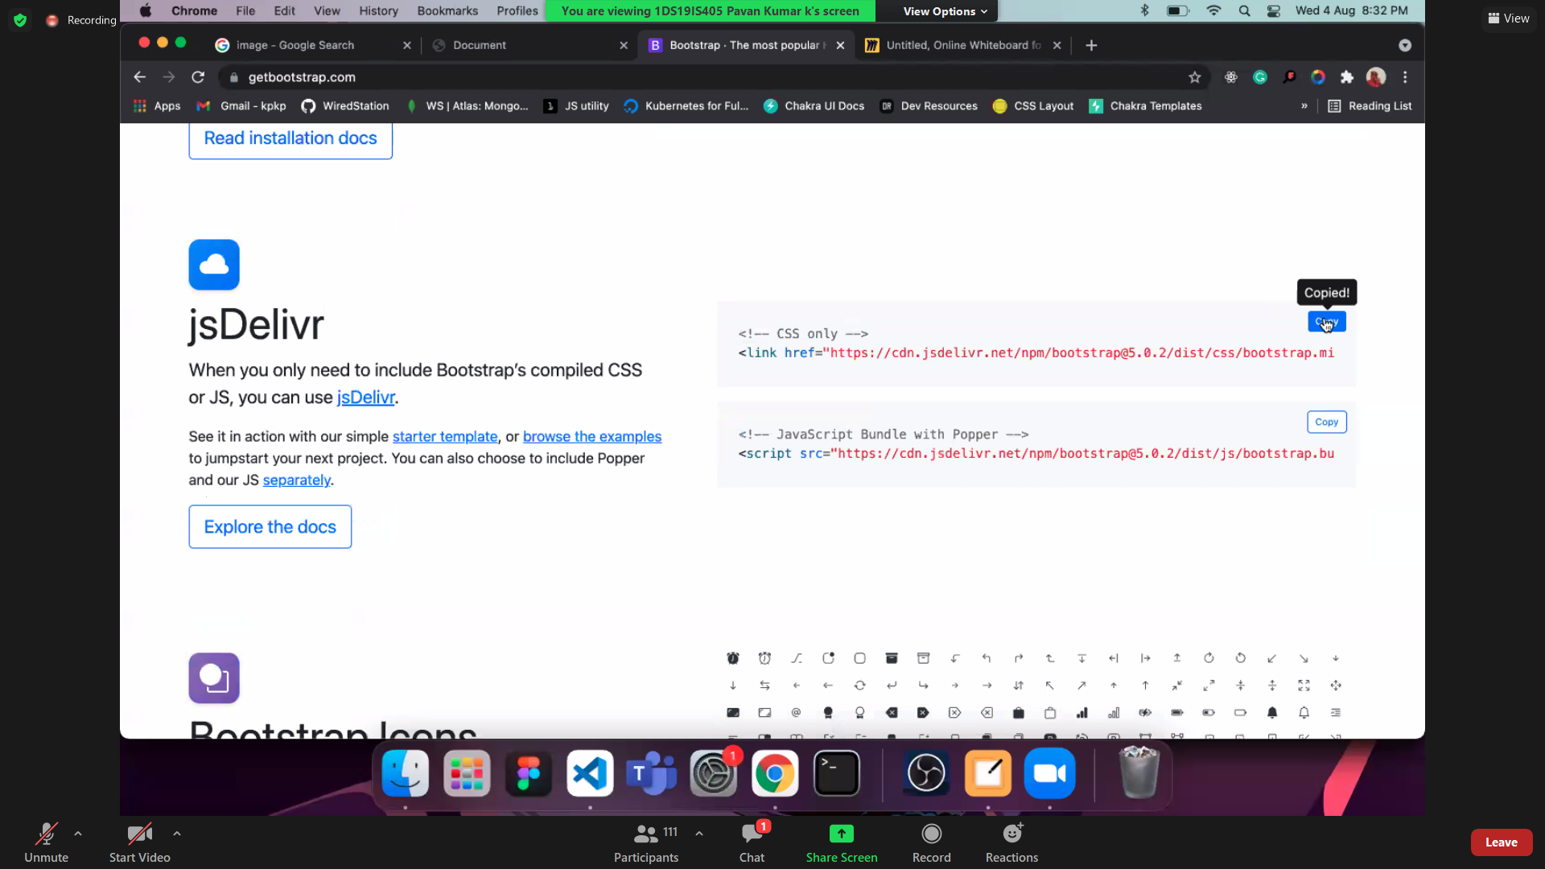

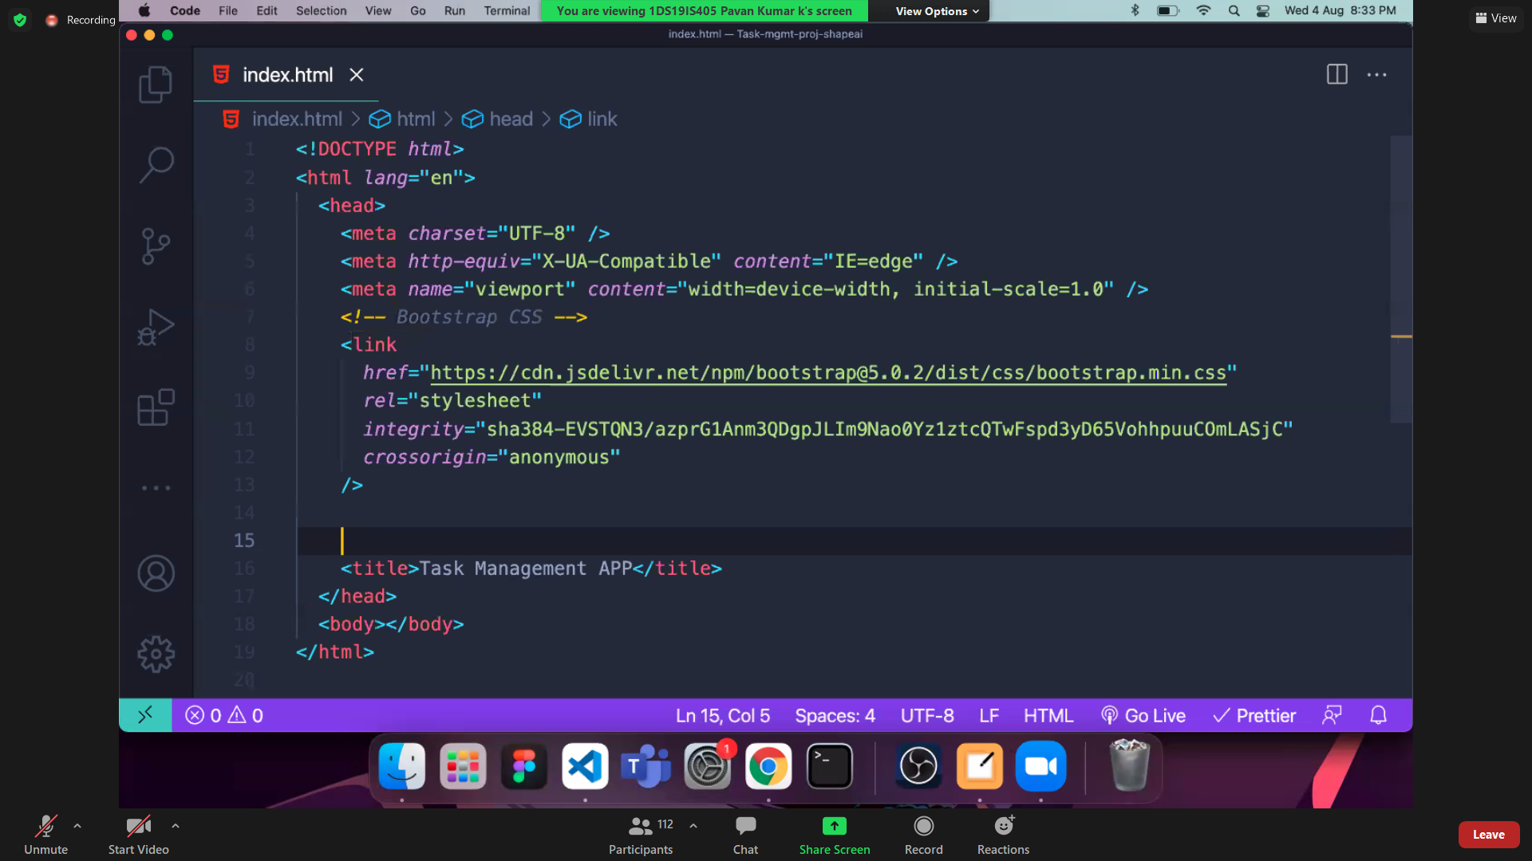

Changed the comment.

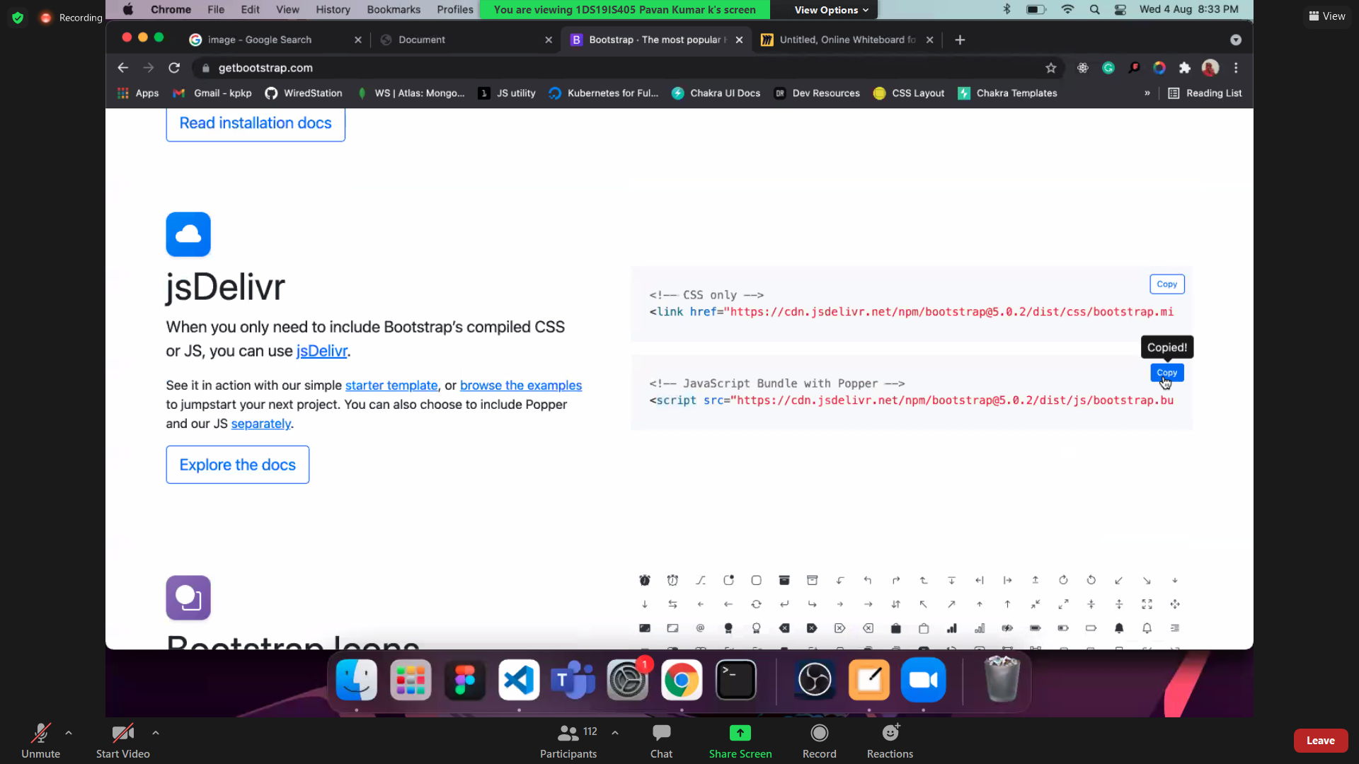

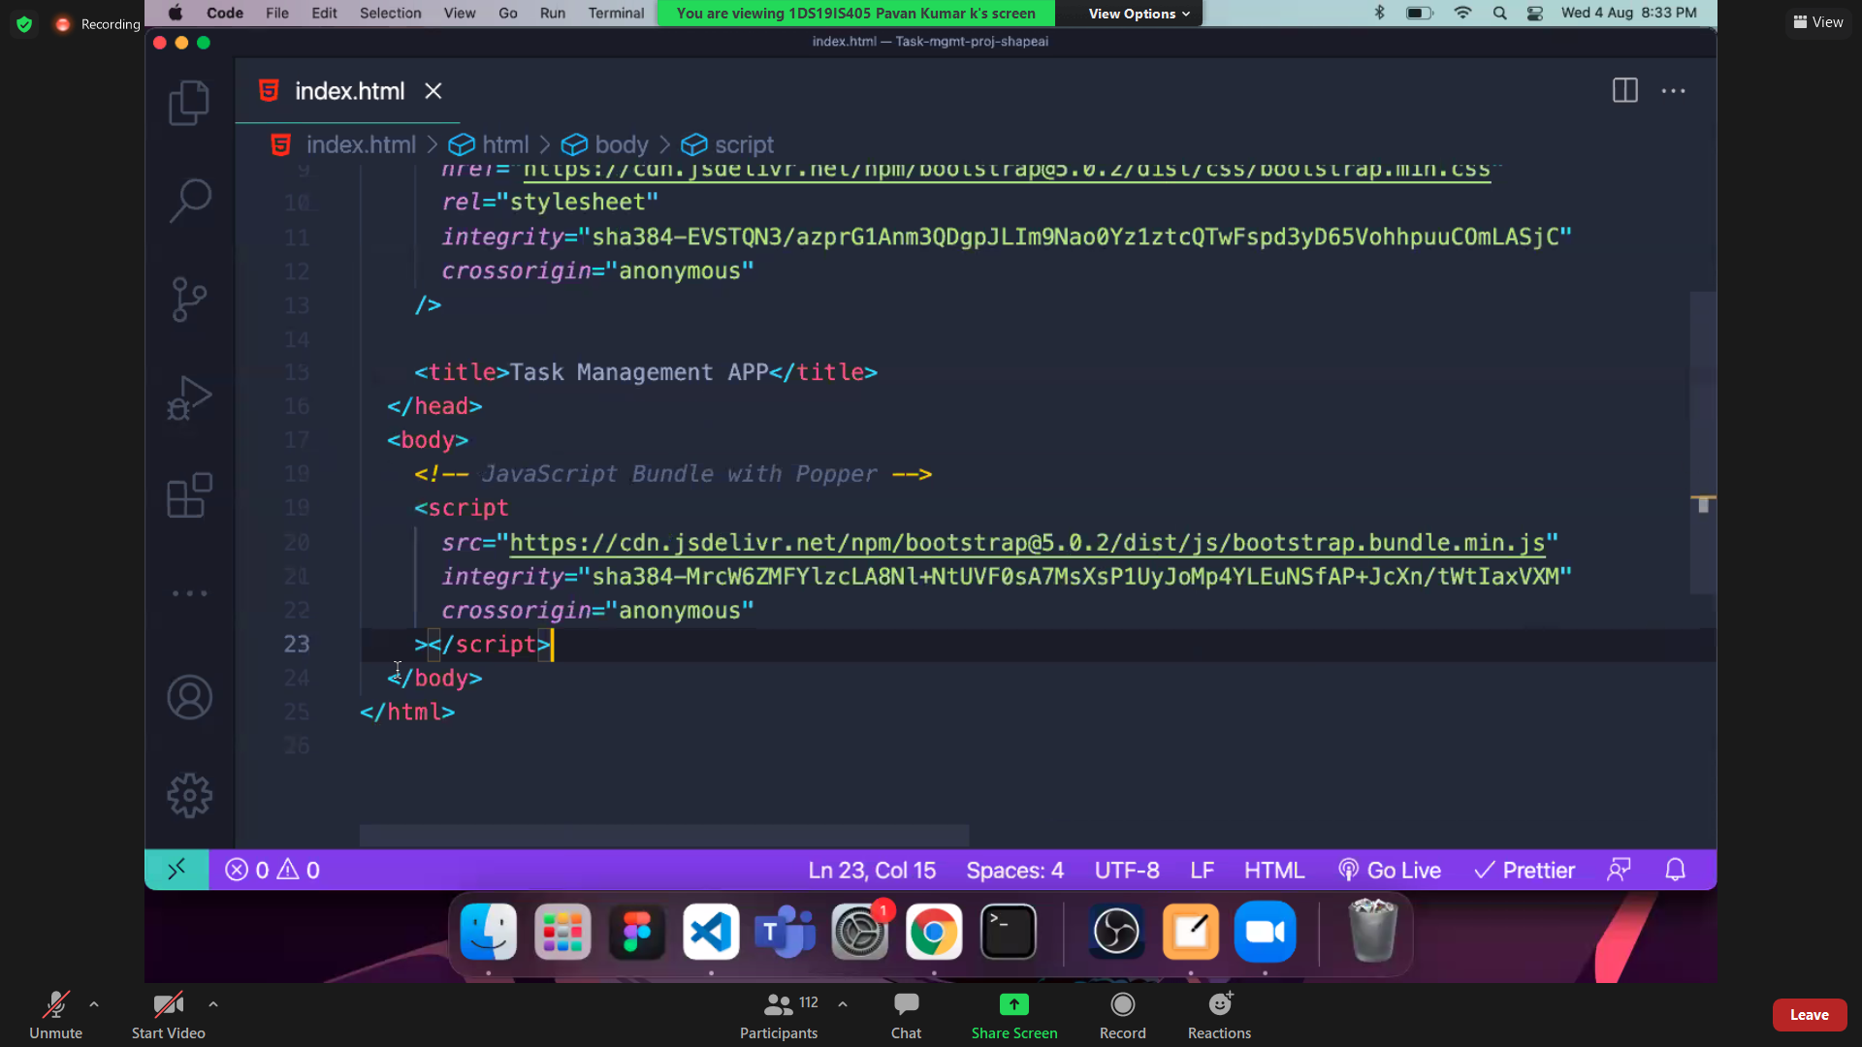

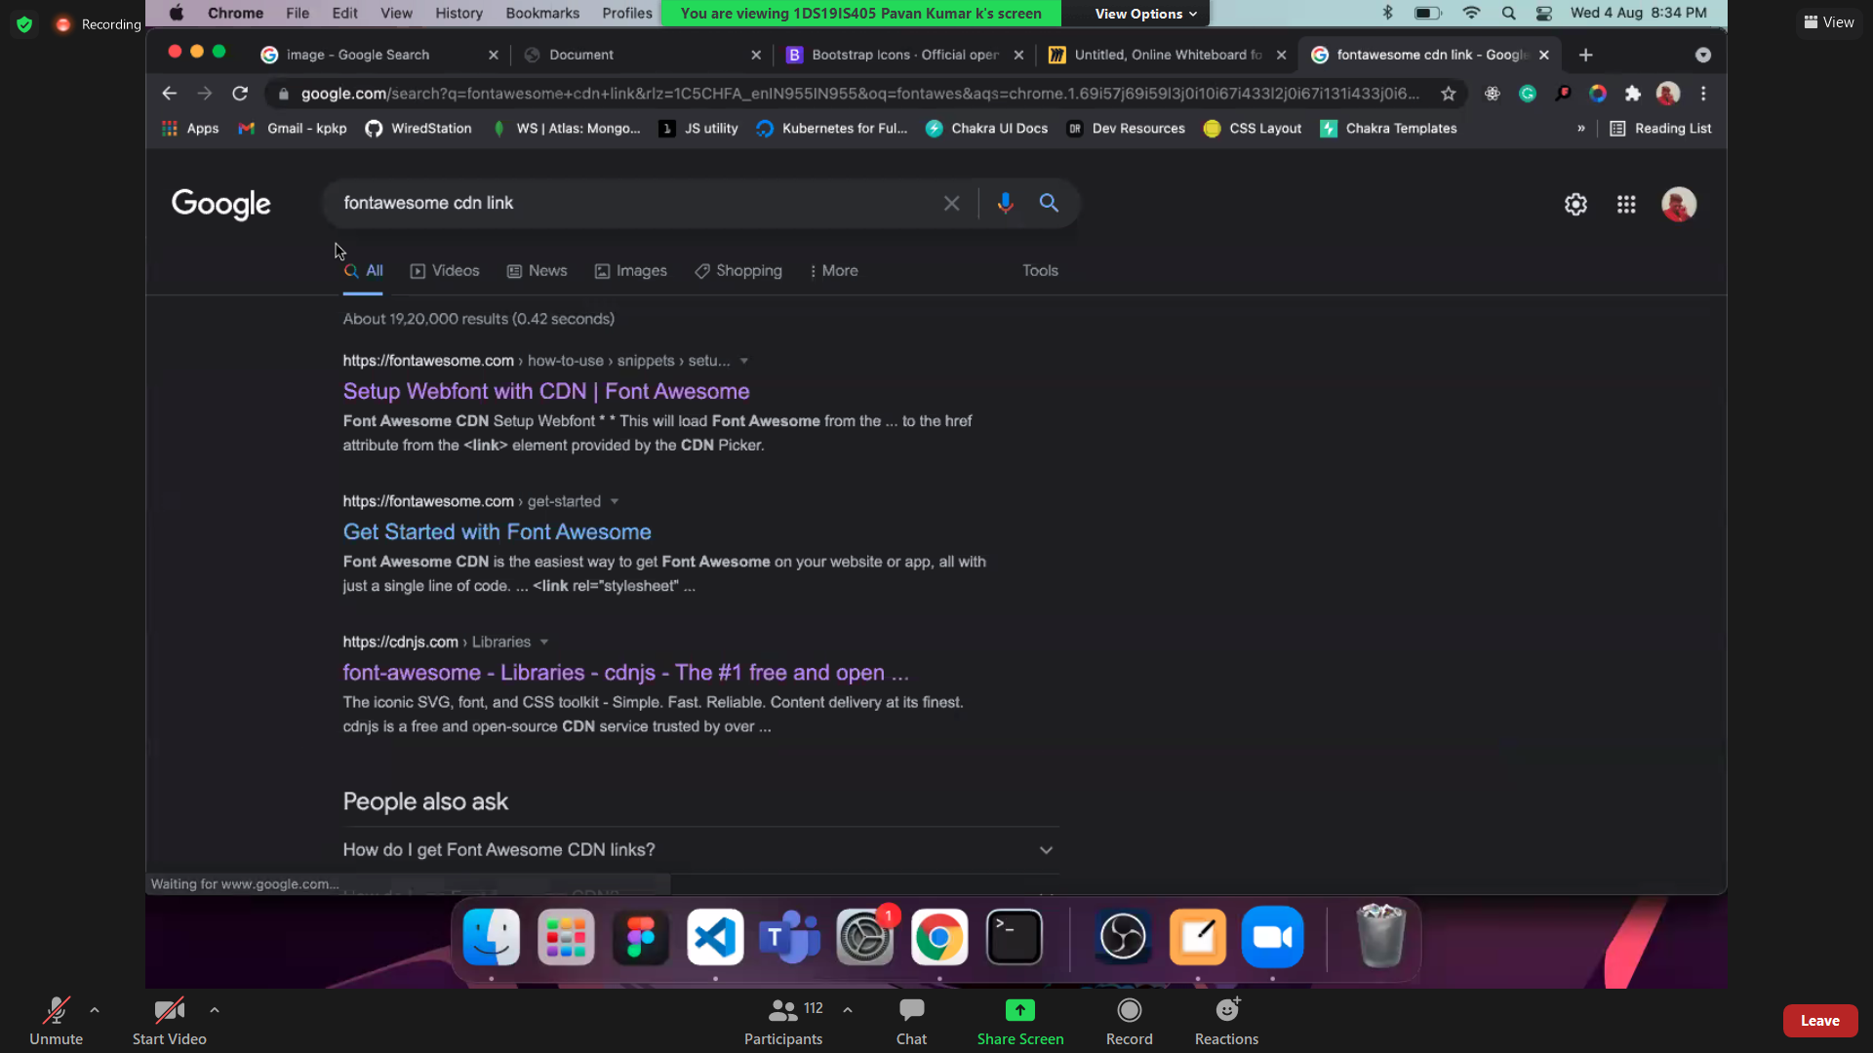

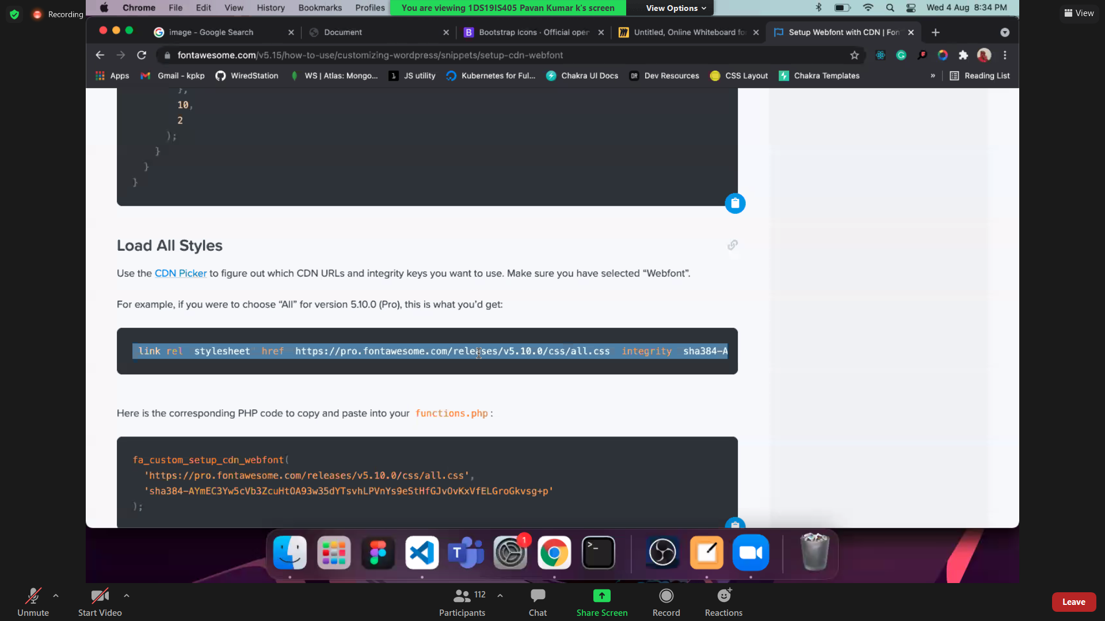

<link rel="stylesheet" href="https://pro.fontawesome.com/releases/v5.10.0/css/all.css" integrity="sha384-AYmEC3Yw5cVb3ZcuHtOA93w35dYTsvhLPVnYs9eStHfGJvOvKxVfELGroGkvsg+p" crossorigin="anonymous"/>

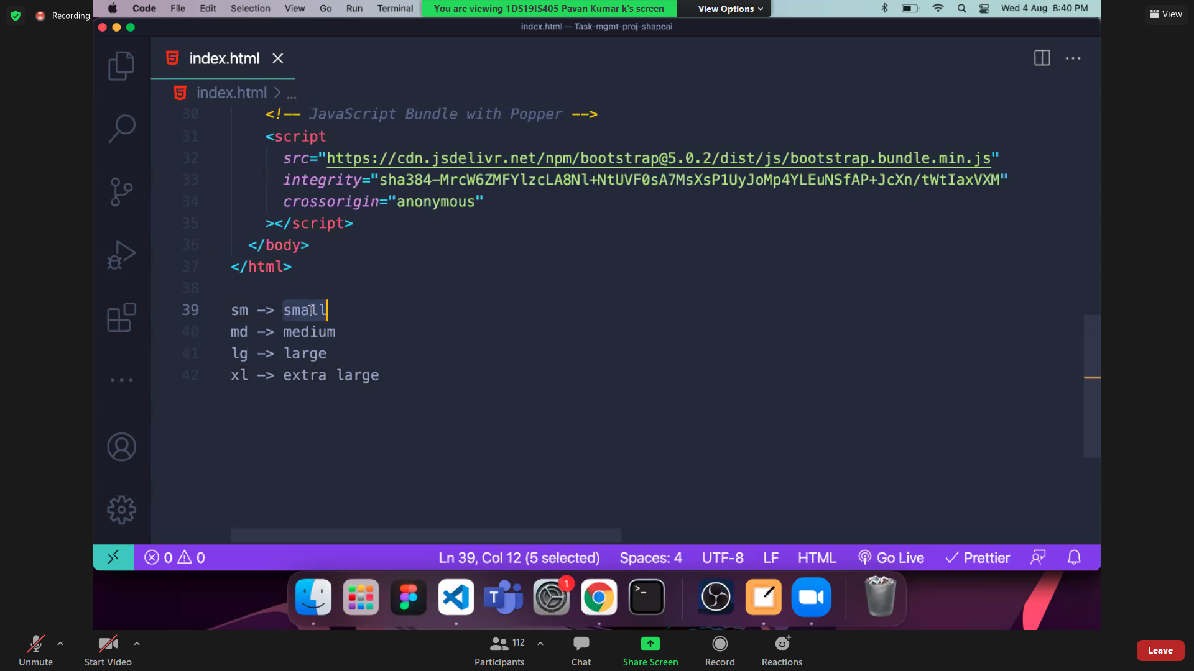

<https://getbootstrap.com/docs/5.1/utilities/spacing/>

#ebf3ff

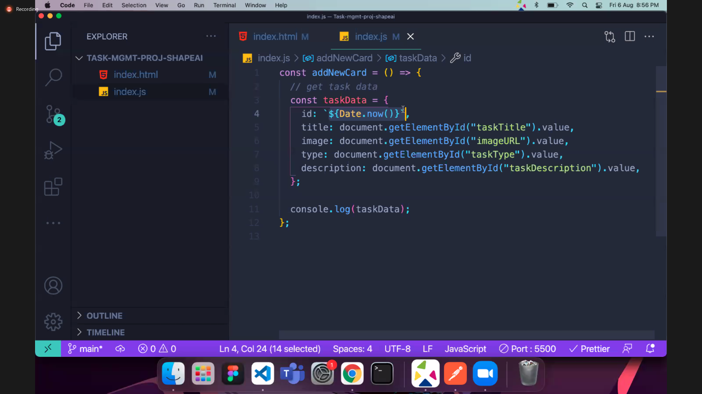

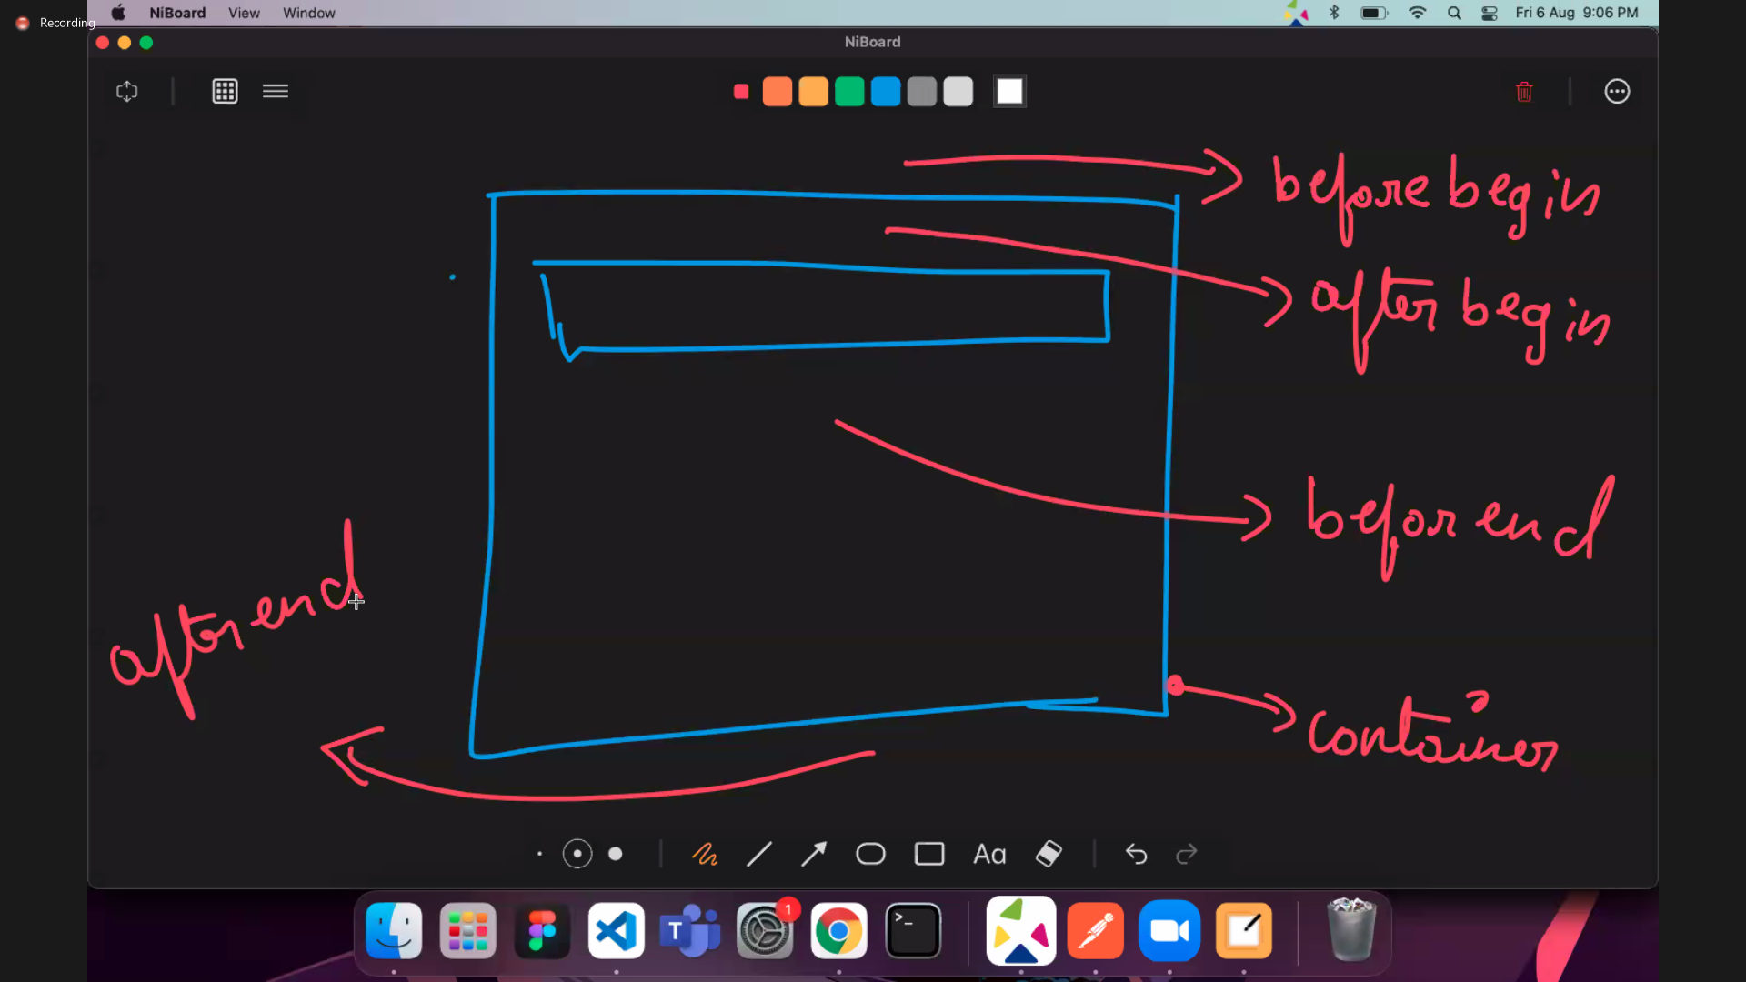

<https://github.com/pavankpdev/Task-mgmt-proj-shapeai-B-C-A>